AsiaHaptics Sample for Word
Hiroyuki Kajimoto*, Hideyuki Ando, Ki-Uk Kyung
AsiaHaptics Program Committee
Tsukuba International Congress Center 2-20-3,Takezono,Tsukuba,Ibaraki,305-0032,Japan
contact_asiahpaitcs@vrsj.org
http:// http://asiahaptics.vrsj.org/
Abstract. AsiaHaptics is a new type of international conference for the haptics fields, featuring interactive presentations with demos. AsiaHaptics welcome for all attendees related to / interest in haptic hardware, human haptic perception, and other haptic applications, not only in Asia but around the world. AsiaHaptics will be held biannually to alternate the World Haptics Conference.
Keywords: asiahaptics, demonstration, haptics
- Introduction
AsiaHaptics is a new type of international conference for the haptics fields, featuring interactive presentations with demos. AsiaHaptics welcome for all attendees related to / interest in haptic hardware, human haptic perception, and other haptic applications, not only in Asia but around the world. AsiaHaptics will be held biannually to alternate the World Haptics Conference.
- Presentation Style & Submission
AsiaHaptics offer a new presentation style based on demos in the exhibition area like a poster presentation, but you will have a main show time projected your demonstration on the center screen. All submissions are required to prepare a video proposal and will be reviewed by the program committee and external reviewers. Publication style will be abstract proceedings and videos [1]. A full paper (6 pages) is optional [2].
The video must be no longer than 5 minutes and all uploaded content (video + PDF(s) + image) must be less than 100 MB. Please make sure that your video is playable on standard PC and Macintosh computers. We recommend that you encode your video as an MP4 using the H.264 codec. Videos from accepted submissions may also appear on web sites previewing AsiaHaptics content [3].
In demo summary, please describe your demo by answering the following questions: What the audience will experience with your demo? How many people can participate at one time? How long is the experience? (It is recommended that the demo experience is less than 3 minutes) How long will you need for setup? How many watt is required? How many people will it take in the booth to explain your demonstration?
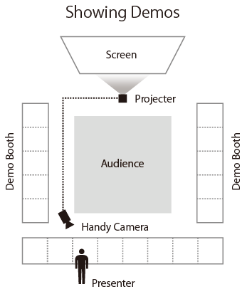
Fig. 1. Presentation Style
- Conclusion
Tsukuba Science City represents one of the world's largest coordinated attempts to accelerate the rate of and improve the quality of scientific discovery [4]. There are 60 national research institutes and two universities including University of Tsukuba and national institute of Advanced Industrial Science and Technology [5]. Tsukuba hosted the Expo'85 world's fair in 1985. more details are on Wikipedia [6].

References
- Smith, T.F., Waterman, M.S.: Identification of Common Molecular Subsequences. J. Mol. Biol. 147, 195-197 (1981)
- May, P., Ehrlich, H.C., Steinke, T.: ZIB Structure Prediction Pipeline: Composing a Complex Biological Workflow through Web Services. In: Nagel, W.E., Walter, W.V., Lehner, W. (eds.) Euro-Par 2006. LNCS, vol. 4128, pp. 1148-1158. Springer, Heidelberg (2006)
- Foster, I., Kesselman, C.: The Grid: Blueprint for a New Computing Infrastructure. Morgan Kaufmann, San Francisco (1999)
- Czajkowski, K., Fitzgerald, S., Foster, I., Kesselman, C.: Grid Information Services for Distributed Resource Sharing. In: 10th IEEE International Symposium on High Performance Distributed Computing, pp.181-184. IEEE Press, New York (2001)
- Foster, I., Kesselman, C., Nick, J., Tuecke, S.: The Physiology of the Grid: an Open Grid Services Architecture for Distributed Systems Integration. Technical report, Global Grid Forum (2002)
- Tsukuba, Ibaraki, http://en.wikipedia.org/wiki/Tsukuba,_Ibaraki

